

Digital Health Modernization/

Secure Message (MHV to VA.gov)

(Q1 2025) |

Version 2

Revision History

| Date | Version | Description | Author |
| --- | --- | --- | --- |
| 3/6/2025 | 2 | Removal of Landing page and addition of Signature Settings | Lichelle Bain |
| 11/7/2022 | 1 | Product Debut | Bryan Riley |

**Table of Contents**

1. Product Overview 4

1.1 Assumptions / Standards 4

2. User Access 4

2.1 Login Methods 4

3. Navigation 4

3.1 Left Navigation 4

4. Functionality 5

4.1 Inbox/Landing Page 5

4.2 Message Details Page 5

4.3 Composing a Message 5

4.4 Folder Management 6

4.5 Search 6

5. Major Issues and Error Messages 6

6. Table of Figures 6

# 1. Product Overview

Secure Messaging on VA.gov will provide Veterans with the same ability to securely contact their VA health care providers as on MyHealtheVet (MHV) today. The new application will employ modern technology and user-centered design to ensure that the tool is accessible, straightforward, and simple to use. Moving this product out of MyHealtheVet and into the VA.gov landscape will also provide a more seamless and consistent experience than was possible on two distinct web sites.

## **1.1 Assumptions / Standards**

In order to maintain consistency across Secure Messaging, there are some approaches that are used throughout the experience to note.

* Error handling exists throughout the application. When a user completes a task, if the result does not complete for any reason, they are presented with an error message (Figure 1a). In addition, the site seeks to adhere to all accessibility requirements (508).

*Figure 1: Example of an error message when a failure occurs*

* The entire experience is mobile responsive, meaning that as it is viewed on small factor devices (tablets and phones) the elements will shrink to provide users with an optimal mobile-friendly experience (Figure 1b).

*Figure 1b: Example of a mobile responsive view versus a desktop view*

# 2. User Access

In the initial release (Phase 0), functionality will not be linked directly to VA.gov. Specific pilot/beta users will be invited to use the experience and their account emails will be ‘whitelisted’ which will allow them entry into the new experience.

Users that are invited to the new experience will need to authenticate into VA.gov and then navigate directly to the URL they will be provided (<https://www.va.gov/my-health/secure-messages/>). They, along with other non-invited users, can still access their legacy/existing MHV Secure Messaging experience by following the links in VA.gov.

## **Logging In to VA.gov to Access the new Secure Messaging**

Invited users will be provided the url to the new experience, which can be accessed by going to <https://www.va.gov/my-health/secure-messages/>. Upon accessing this url, users will have the ability to login using one of the existing VA.gov login options.

Unauthorized users will be redirected to this static page [https://staging.va.gov/health-care/secure-messaging/](https://nam02.safelinks.protection.outlook.com/?url=https%3A%2F%2Fstaging.va.gov%2Fhealth-care%2Fsecure-messaging%2F&data=05%7C01%7Cjoel.calumpong%40bylight.com%7C2b5a036bb1414aac09d808db03c9d955%7C90ae2b3ff88948dea8d4459d51216af8%7C1%7C0%7C638107937704707846%7CUnknown%7CTWFpbGZsb3d8eyJWIjoiMC4wLjAwMDAiLCJQIjoiV2luMzIiLCJBTiI6Ik1haWwiLCJXVCI6Mn0%3D%7C3000%7C%7C%7C&sdata=rATfWD8pQAAfzTvFPv6n06vlEbJQ0K71I%2FeeBD%2Bn22M%3D&reserved=0)

*Figure 2a: Logging into VA.gov, main screen with button highlighted and resulting modal with login options*

## **Accessing the new My HealtheVet Experience Landing Page**

After logging in, approved users will land on the main landing page (Figure 2b).

Users have the following Secure Messaging capabilities from within the landing page:

* Go to Inbox
* Start a new message

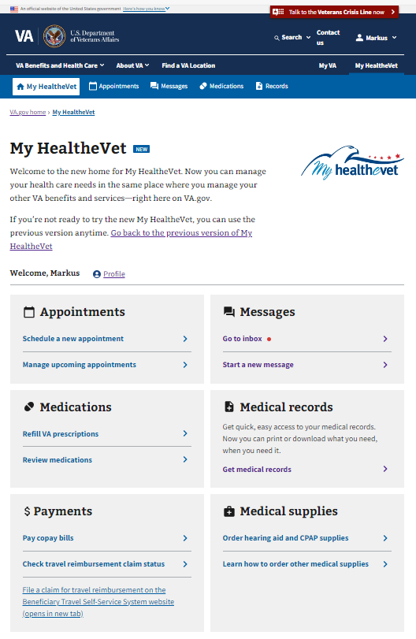

*Figure 2b: Landing Page of the new My HealtheVet experience*

# 3. Navigation

In order to navigate around Secure Messaging on VA.gov, Veterans are provided with several navigation techniques.

## **3.1 Back Breadcrumbs**

* + Appears when the user starts a task that takes them to another page from one of the Left Navigation pages. Clicking on this back breadcrumb will return the user to the Left Navigation page they came from.

*Figure 3a: Breadcrumbs*

# 4. Functionality

Users of Secure Messaging can navigate throughout the experience using the aforementioned navigation patterns. Below is a description of the various types of functionalities that users can perform while authenticated.

## **4.1 Inbox**

* + Sorting/Pagination to access the desired message efficiently
  + Messages appear throughout the application in list form
  + Preferences that have been set in the legacy SM may restrict users from seeing old messages

## **4.2 Start a new message**

## Users **of Secure Messaging can start a new message from any Left Navigation page using the “Start a new message” link. From there, users have the below functionality available to them.**

* + Select a Triage Group and Category for the message
  + Attach a file to the message (with file size/type limitations)
  + Send a message (via starting a new message or replying to a pre-existing message)
  + Discard a draft (permanent deletion of a message that was never sent)
  + Save/Auto-Save Draft Message as you are typing a message
  + Replies to messages can only happen within 45 days of the message receipt

*Figure 4a: Start a new message link*

## **4.3 Message Details Page**

Upon entering a message thread, users will view the message details along with previous messages within the thread. From within this page users can read the contents of the message as well as perform other key actions

* + Print messages
  + Move message to another folder
  + Reply to message (unless restricted by settings*)
  + Delete a message (these move to the Trash folder and are not permanently deleted)
  + Download any attachments that are within the message

* Messages may be restricted from replying if they are older than 45 days

*Figure 4b: Message Details Page*

## **4.4 Folder Management**

* + System Folders are automatic and cannot be modified or deleted
    - Sent Messages contains all completed sent messages
    - Draft Messages contains all save messages that haven’t been sent
      * No attachments can be saved on draft messages
      * Deleting a draft message is permanent
    - Trash
      * Contains ‘deleted’ messages that are not permanently deleted
      * Messages can be moved back to other folders
  + Personal Folders (My folders)
    - Creation of new folders
    - Rename of existing folders
    - Deletion of empty existing folders

*Figure 4c: System folders*

*Figure 4d: Mobile and Desktop Views of Personal folders (“Cardiologist” and “Eye Doctor” are just examples, not defaults)*

## **4.5 Filtering messages**

## Users **of Secure Messaging can filter messages from any Left Navigation page using the Filter component on the page. Using this**

* + Basic Filtering for a Message
    - Allows a user to find messages by entering info from one of these fields: to, from, message ID, or subject
  + Advanced Filtering for a Message
    - Allows a user to find more specific messages by entering info about how they were categorized and specifying a date range.

*Figure 4e: Filtering component, collapsed and expanded*

## **4.6 Signature Settings**

*Users can add a signature and signature title to be automatically added to all outgoing secure messages.*

* *Users may navigate to VA Profile to edit their signature setting*
* *A link is provided on the Start of new Message page for users with the signature settings turned on.*

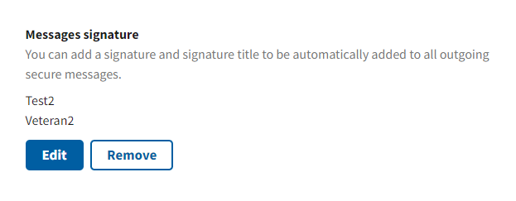

*Figure 4f: VA Profile, Signature settings section*

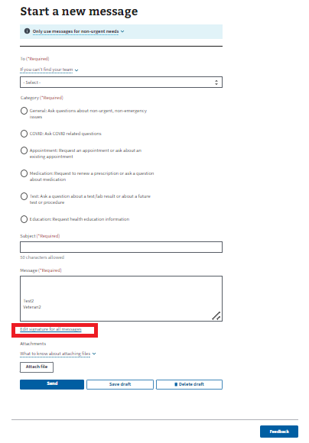

*Figure 4g: Start of new message page with link to VA Profile*

# 5. Major Issues and Error Messages

No Major Issues known or documented at this time.

# 6. Table of Figures

No Table of Figures information documented at this time.